MFM 1P WS 2.1 Interior Angles in Triangles NAME:

- Classify each triangle using its side length.

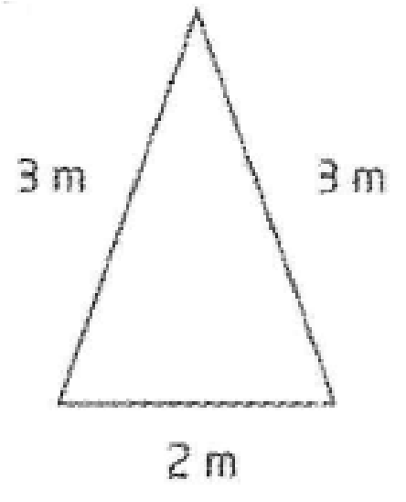
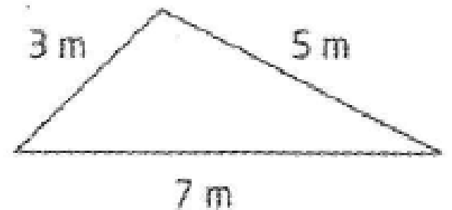
b) c)
a)

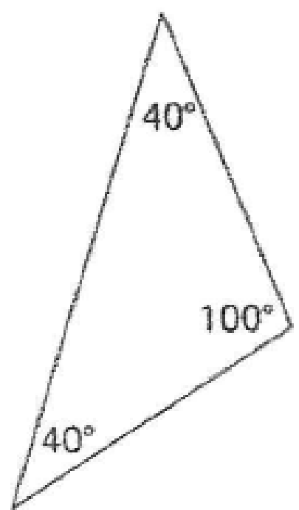
- Classify each triangle as acute, obtuse or right.

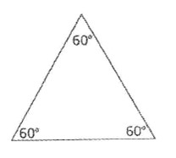

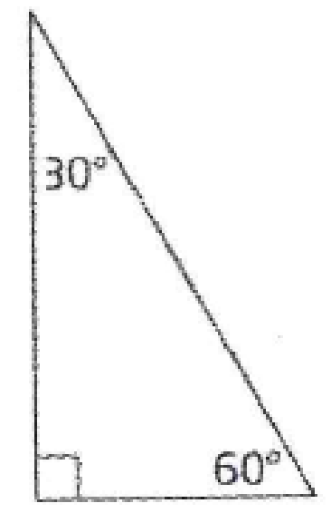
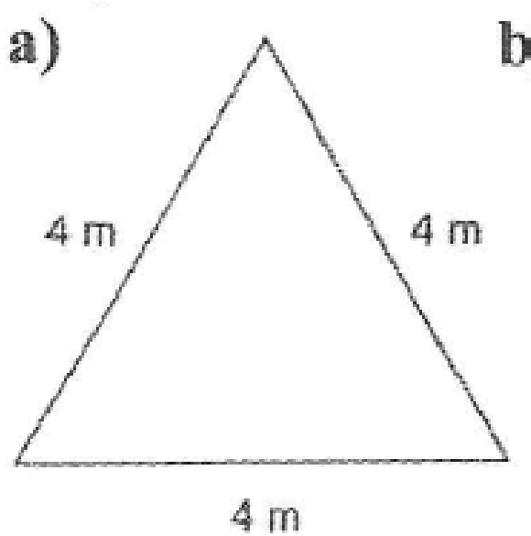

- Classify each triangle in two ways.

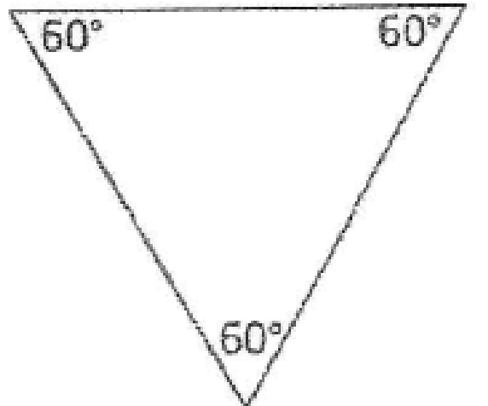
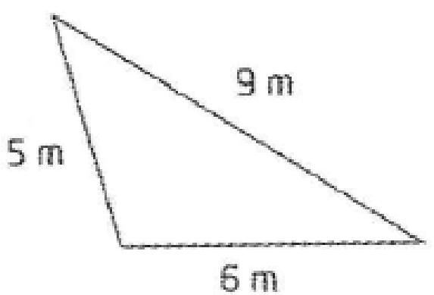
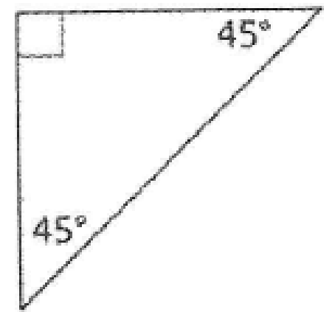
a) b)

c)

- Find the measure of each unknown angle.

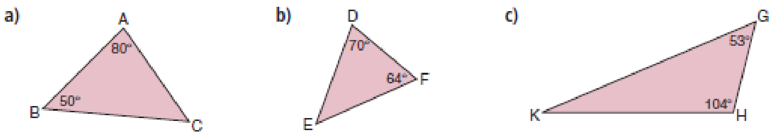

- For each set of angles, can a triangle be drawn. Explain your answer.

- Can a triangle have two 90° angles? Explain.

- Find the measure of each unknown angle.

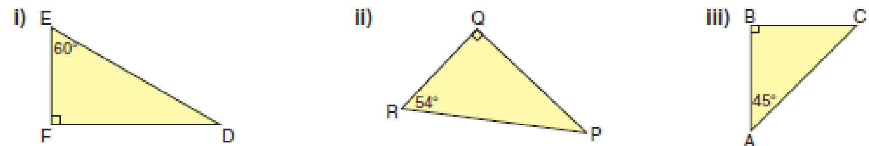

- In each isosceles triangle, ABC, determine the measures of angles A and B.

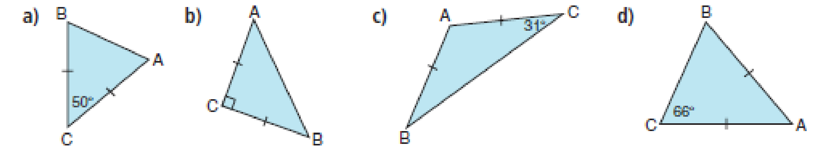

- Determine the angle measure indicated by each letter.
